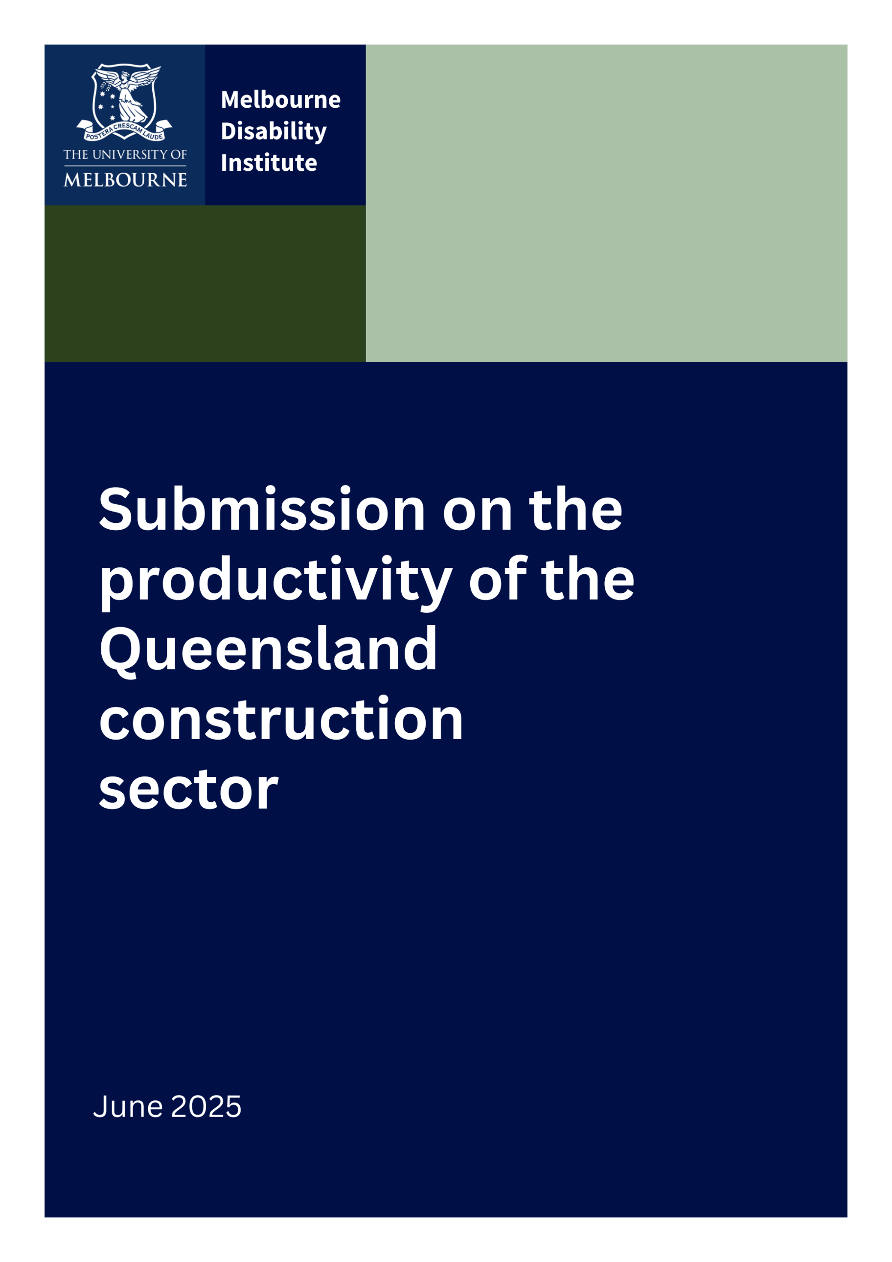



Submission on the productivity of the
Queensland construction sector
Executive Summary
This submission from the Melbourne Disability Institute recommends that:
Queensland should continue to implement the National Construction Code’s Liveable Housing Design Standard (the Standard) because it not only enhances the productivity of the housing industry but, even more significantly, it improves overall economic efficiency the appropriate aim for government policy¹. This is achieved through contributions to productive efficiency (i.e., productivity), allocative efficiency and dynamic efficiency. Not only are the benefits of the Standard higher than the costs, but the Standard also aligns best with the needs of Queenslanders and helps to ‘future-proof’ the Queensland housing stock.
This submission therefore refutes the arguments of Queensland housing industry peak bodies that the Standard decreases the productivity of the housing industry. The industry argument is flawed because it mistakenly focuses exclusively on immediate costs when there are current and future benefits, housing industry productivity gains, quality of life improvements, employment gains for people with disability and the housing stock can be used much more efficiently when accessibility needs change. We argue in accordance with the Terms of Reference that achievement of overall economic efficiency (i.e., social efficiency) is a “key issue” to be considered in evaluating and prioritising reform options.
The Melbourne Disability Institute
The Melbourne Disability Institute (MDI) is an interdisciplinary research Institute at the University of Melbourne. Our Vision is “to transform the well-being, health, social and economic outcomes for people with disability”.
As part of our Mission “we bring people with disability, families, government and non-government organisations together with researchers to co-produce research that has real-world impact on policy and practice and helps to build a more inclusive and equitable society”.
Accessible housing is an area of major research interest, knowledge translation and impact for MDI. In 2021, MDI worked closely with the Australian Network for Universal Housing Design (ANUHD) and the Summer Foundation to make submissions²⁻⁴ to the Australian Building Codes Board (ABCB) Regularly Impact Statement (RIS) into the benefits and costs of minimum accessible standards for new housing. Our research demonstrated that contrary to the RIS prepared by the economic consultants engaged by the ABCB, the benefits of accessible housing outweigh the costs significantly. This research then provided the evidence for Ministers to change the National Construction Code in 2022 to include minimum standards for all new housing.

Background
Every Australian deserves a home that is safe and secure and meets their needs in any life circumstance. Accessibility is not just essential for people with disability. It is also essential for older Australians who have shown a clear desire to age in place. Therefore, accessibility is an essential feature to “future-proof” Australia’s housing stock as Australian society ages.
For decades, the housing industry and governments committed to transform construction practices voluntarily to ensure housing was adaptable to occupants’ changing accessibility needs throughout the life of the dwelling—and failed to do so^{5,6}. Over the twenty years, housing practices gradually transformed to include some accessible features, but not to a consistent or reliable standard⁶ to be useful. It was quite clear from this experience that without mandatory requirements, new housing would not achieve adequate accessible standards.
In 2022, the NCC was amended “to ensure that housing is designed to meet the needs of the community, including older people and those with a mobility-related disability”⁷. The Standard⁸ requires a dwelling to be:
- easy to enter;
- easy to navigate in and around;
- capable of easy and cost-effective adaptation; and
- responsive to the changing needs of occupants.
Now implemented in six states and territories, the Standard ensures reliable physical access in new housing for both renters, buyers and visitors. Queensland builders have implemented the Standard since October 2023.

Refuting the concerns of the housing industry peak bodies regarding increased cost and decreased productivity.
The Master Builders Queensland and the Housing Industry Association⁹ continue to argue against the implementation of the Standard, citing increased cost of building and decreased productivity. However, cost and productivity are not the same and benefits are broader than productivity. The Australian Productivity Commission makes this point clealry in its coverage of the term “productivity” and its relationship to effectiveness and efficiency¹. It is clear in their reasoning that for government decisions to improve overall community wellbeing the relationship between all levels of efficiency should be carefully considered. For example, improving economic efficiency can involve reducing the costs of production per unit of output (i.e., a focus on the suppy side to improve production efficiency or productivity), matching the supply of goods and services to those most desired by individuals (i.e., adding the demand side to improve allocative efficiency), and/or removing barriers to innovation and flexibility (i.e., improving dynamic efficiency). They also noted that in moving to the production possibility frontier, choices are available that impact distribution and equity considerations.
Starting with costs, an accurate cost is difficult to calculate; however, the most recent estimate is that the Standard imposes an additional 1.2% cost for Class 1a buildings and 0.8% for Class 2 buildings¹⁰. In 2020, the ABCB Decision Regulatory Impact Statement¹¹ (RIS) found that the costs of implementing the Standard outweighed the benefits based on analysis undertaken by the Centre for International Economics (CIE). However, the research by MDI that was led by Andrew Dalton and Professor Rob Carter comprehensively refuted this conclusion^{12,13}. It found that the benefits would exceeds the costs because:
- The CIE analysis did not include all of the benefits, while including all of the costs, and so did not comply with advice from the Office of Best Practice Regulation¹⁴. In order to overcome these deficiencies, Dalton and Carter recommended that the Cost Benefit Analysis (CBA) should be based on the Willingness to Pay (WTP) Approach, rather than the Problem Reduction approach favoured by CIE (with appropriate exclusions to avoid any double counting of benefits)^{12,13}. After discussions with the CIE on the MDI/Summer Foundation Submission, further supplementary advice was provided by Dalton and Carter¹³. Note that the WTP research was undertaken by the CIE to estimate societal benefit from improved accessibility,

- Dalton and Carter noted in their advice that the principle of symmetry in economic evaluation strongly suggests that if only a portion of the benefits are to be counted (as in the CIE’s preferred Problem Reduction Approach), then the costs needed to be apportioned between those receiving the benefits using an appropriate attribution formula. This was not done.

- The CIE also chose to value the additional space used to provide accessible features at zero, on the basis that they did not know its future value and so could not estimate its increase in value! This is an extreme assumption, and a much more balanced approach is to maintain the real value of this space, which is what Dalton and Carter built into their estimates. It was significant that benefits of accessible design were valued by the general community as substantiated by the CIE’s own stated preference survey to measure willingness to pay (WTP). Further, around half of the respondents in their survey of 2062 respondents indicated that they considered accessibility to some extent when choosing their current home and 70 per cent indicated they would prefer their next home to have at least some accessibility features^{11 (p.208)}.

- The value of informal care included in the CIE analysis was also a significant underestimate and Dalton and Carter included the most up-to-date and reliable estimates in their analysis.

- Finally, the discount rate applied by CIE, at 7 per cent, although in accordance with Office of Best Practice current guidance¹⁴, is out of date and considered by many analysts to be too high. For illustrative purposes Dalton and Carter showed the effects of including a discount rate of 3 per cent. At the time, long-term bond rates in Australia were close to zero and are now 4.5 per cent, still well below the rate used by CIE. This assumption is particularly important when analysing the benefits and costs of accessible housing because all of the costs are upfront and all of the benefits are in the future.
MDI, working with the Summer Foundation, also commissioned some qualitative analysis by Dr Ilan Wiesel¹⁵, who is a human geographer at the University of Melbourne with a particular interest in disability and housing. The Office of Best Practice Regulation¹⁴ recommends that all CBA's should include qualitative as well as quantitative data. His survey generated nearly 1,150 responses and this was followed up with more than 40 individual interviews. This is still the most comprehensive survey and qualitative analysis of the impact of housing accessibility on people with disability ever undertaken in Australia. The findings included that over 80 per cent of respondents found that inaccessible housing had negatively affected their ability to socialise with friends and family and more than 30 per cent reported that inaccessible housing had reduced their capacity to work.
In 2022 the Building Ministers Meeting considered the feedback from all sectors of the industry and community, and decided that mandated access requirements in all new housing would result in significant and lasting benefit to Australians¹⁶. The research from MDI was critical to that decision.
This submission argues that the continued implementation of the Standard in Queensland not only increases productivity of the housing industry but also supports the priorities of the Australian and Queensland Governments.

The Standard assists productivity in the housing industry
MDI’s view is that while productivity is an extremely important contributor to costs and cost reductions, costs are not driven by productivity alone. There is an important interaction between costs, quality standards and productivity that needs to be carefully considered. Costs may increase, for example, but the per unit cost decrease because of associated output increases. This may occur due to improvements in productive efficiency (e.g., better factor mix, new technology), allocative efficiency (e.g., demand increases due to better alignment with consumer needs and demand) or dynamic efficiency (e.g., resources are better aligned with both current and future preferences of the population). Very importantly, actions to reduce costs should not be achieved by reducing essential quality standards or standards that provide future as well as current benefits. This is particularly the case when considering accessibility standards.
Therefore, when considering how best to reduce costs of new housing, this should not be at the expense of accessibility standards.
In addition, accessible housing that is future proofed and so means people can age in place or continue to live in a dwelling when their accessibility needs change, mean that ‘friction’ in the housing stock is reduced. This is a particularly important attribute given current housing shortages.
Further we note that the Standard will increase productivity of the housing industry in the following ways:
- Generally, a nationally consistent approach to building standards has been found to have significant productivity benefits to the construction industry through breaking down inconsistencies between building standards across state and territory borders¹⁷. Given that six states and territories have already implemented the Standard with NSW and WA currently expected to follow, Queensland can expect increased productivity in this area by continuing to implement the Standard.

- Implementation of the Standard is within established building practice¹⁸; requiring no new technology and minimal added building materials. It is easily adopted, and information and training is readily available¹⁹.

- The real causes of housing construction inefficiencies include the vagaries of supply and demand, the interdependence of many suppliers and contractors, and poor quality of work generally, requiring call-backs on defects^{20, 21}. The implementation of this Standard has little to do with these broader inefficiencies.

The Standard supports government policy priorities

Australian Government priority: Making housing accessible and affordable for all Australians
In 2022 and 2023, two of the authors, Professors Bonyhady and Deane, Co-Chaired the NDIS Review²⁴ and were a member of the Independent Panel, respectively. The Terms of Reference required the reviewers to put people with disability back at the centre of the NDIS, restore trust and confidence and ensure that the Scheme is sustainable for future generations.
A key conclusion from the Review was that it is impossible to fix the problems with the NDIS, without addressing the issues outside the Scheme, including critical shortages of affordable and accessible housing. These challenges cannot be met through the very costly Specialist Disability Accommodation program or social housing programs.
The Review recommended in Action 9.11 that: All Australian governments should agree on and publish a targeted action plan for housing under Australia’s Disability Strategy… including a commitment for all remaining jurisdictions to sign-up to the Liveable Housing Design Standards in the National Construction Code.
Many reports and organisations, from the United Nations to Royal Commissions, have called for mandated access requirements in all new housing to assist making housing accessible and affordable for all Australians:
- The United Nations called Australia to account in 2019 for its lack of action in mandating accessibility in housing²². Six out of eight states and territories have since implemented the Standard in their building legislation¹⁰. Queensland led the way demonstrating the State’s commitment to the human rights of all Queenslanders.

- Recent recommendations by the Royal Commission into violence, abuse, neglect and exploitation of people with disability in 2023 urged State and Territory governments to implement the Standard for all new dwellings if they have not done so already²³.

- The Royal Commission on Aged Care Quality and Safety in 2021 found that the lack of accessible housing impacted directly on the quality of life of older people. The Commission also found there was a clear link between the quality of housing and premature entry to aged care²⁵.

- The Australian Intergenerational Report 2023²⁶ predicts that by 2063 the number of people aged 65 and over will more than double and the number aged 85 and over will more than triple. Population ageing will be an ongoing economic and fiscal challenge for the health, community and aged care responsibilities of all Governments.

Queensland Government priority: Growing the economy to drive down the cost of living and give Queenslanders a better lifestyle and a place to call home
The implementation of the Standard will assist the Queensland Government’s priority²⁷ to drive down the cost of living, and give Queenslanders a better lifestyle and a place to call home in the following ways:
- Affordable and accessible housing is known to be a prerequisite for more vulnerable citizens to find and maintain employment, to live a healthy lifestyle and to build community connection¹⁵.

- While many homes will require modification at some time to meet individual needs, the Standard will allow for easier, faster and cheaper modification.

- Accessibility in the home allows for timely discharge from hospital and the provision of home-based care, and delays placement in specialised residential facilities.

- Accessible housing facilitates social inclusion by allowing people who need access to visit other people’s homes, and participate in family and community life.

Conclusion
In summary, the construction of new housing and adapted existing stock should “meet the needs of the community, including older people and those with a mobility-related disability” ⁷, so that people can remain in their own homes and connected to their families and communities for as long as possible. Queensland leads the way in implementing the Standard.
The housing industry peak bodies have objected to this important reform. They argue that the Standard adversely impacts construction sector productivity. We argue with the Australian Network for Universal Housing Design and others that the implementation of the Standard in Queensland not only assists productivity but also supports broader government priorities and improvements in social welfare.
The quest for increased productivity in the housing industry is a worthy endeavour but should not be at the expense of safety and inclusion for ordinary Queenslanders, old or young, renter or homeowner, occupant or visitor. We all need homes that are safe and secure, and meet our needs in any life circumstance and that means that we need a housing stock which is “future-proof” to meet changing individual and societal needs. Put in economic terms, there is a danger that a narrow focus on cost containment may not only decrease productive efficiency, but adversely affect allocative efficiency, dynamic efficiency and overall social welfare.

Professor Bruce Bonyhady AM Professor Rob Carter
Executive Chair and Director Foundation Chair in Disability Economics
Melbourne Disability Institute Melbourne Disability Institute

Professor Kirsten Deane OAM
Deputy Director
Melbourne Disability Institute
1 June 2025

References
- The Productivity Commission) “On Efficiency and Effectiveness: Some Definitions”, Staff Research Note, Canberra. 2013.
- Accessible Housing: The Way Forward
Response to the Australian Building Codes Board Consultation RIS. Submitted by the Melbourne Disability Institute and the Summer Foundation, 31st August 2020
- Accessible Housing: The Way Forward
Supplementary Information provided to the Australian Building Codes Board Consultation RIS. Submitted by the Melbourne Disability Institute and the Summer Foundation, 6th October 2020
- Bonyhady, B. Position Statement on the cost-benefit analysis of the proposed regulation for accessible housing, 29 June 2021.
- National Dialogue on Universal Housing Design. Strategic plan. 2010; https://www.dss.gov.au/sites/default/files/documents/05_2012/national_dialogue_strategic_plan.pdf. Accessed January 20, 2015.
- ANUHD, RI Australia. Report on the progress of the National Dialogue on Universal Housing Design 2010-2014. In. Sydney. 2015.
- Australian Building Codes Board. National Construction Code Volumes 1&2. In: Australian Building Codes Board; 2022: http://www.abcb.gov.au/.
- ABCB. Standard for Livable Housing Design. In. Canberra. 2022.
- Killoran M, Fellows T. Public Works Minister refuses to delay housing code that could add $20k to cost of home. Courier-Mail. July 11, 2023.
- Building Commission NSW. Livable housing requirements in NSW: Discussion paper. Sydney. 2025.
- Centre for International Economics. Proposal to include minimum accessibility standards for housing in the National Construction Code: Decision Regulation Impact Statement. Sydney: Australian Building Codes Board. 2021.
- Dalton A and Carter R (2020) Economic advice provided to assist with responses to the Consultation Regulation Impact Statement on minimum accessibity standards for housing in the National Construction Code, prepared for the Melbourne Disability Institute and the Summer Foundation,19 August 2020.
- Dalton A and Carter R (2020) Economic advice provided to assist with responses to the Consultation Regulation Impact Statement on minimum accessibity standards for housing in the National Construction Code – Supplementary Information, prepared for the Melbourne Disability Institute and the Summer Foundation, 6th October 2020.
- Office of Best Practice Regulation. Guidance Note: Cost Benefit Analysis. In: PMC, ed. Canberra. 2016.
- Weisel A (2020) “Living with disability in iinaccessable housing: social, health and economic impacts - Final Report”, School of Geography, The University of Melbourne, 22 October, 2020.
- Building Ministers Meeting. Communique, April 2021. In: Department of Industry, ed. Canberra: Australian Government; 2021.
- Productivity Commission. Reform of building regulation. 2004; http://129.3.20.41/eps/othr/papers/0506/0506007.pdf. Accessed July 24, 2010.
- Winkler D, Martel A, Chen Y, Greaves T. Audit of accessible features in new houses, apartments and townhouses. 2021.
- ABCB. ABCB Livable Housing Design Handbook. In. Canberra. 2022.
- Dalton T, Wakefield R, Horne R. Australian suburban house building:industry organisation, practices and constraints. Melbourne. 2011.
- Dalton T, Chhetri P, Corcoran J, Groenhart L, Horne R. Understanding the patterns, characteristics and trends in the housing sector labour force in Australia. Melbourne. 2013.
- Committee on the Rights of Persons with Disabilities. Concluding observations on the combined second and third periodic reports of Australia. United Nations. 2019.
- Royal Commission into violence, abuse, neglect and exploitation of people with disability. Final Report. 2023.
- NDIS Review. Final Report of the Independent Review of the National Disability Insurance Scheme. 2024.
- Royal Commission into Aged Care Quality and Safety. Final report: care, dignity and respect. Canberra: Australian Government. 2021.
- Australian Government. Intergenerational Report 2023: Australia’s Future to 2063. 24th August, 2023.
- Queensland Government. Government's objectives for the community. 2025; https://www.qld.gov.au/about/how-government-works/our-priorities/governments-objectives-for-the-community. Accessed May 10, 2025.

